**NAAN MUDHALVAN ASSIGNMENT**

**LOGO**



**BLOG**

**LINK:** [**https://moneyhandlingforstudents.blogspot.com/2023/08/money-handling-for-students.html**](https://moneyhandlingforstudents.blogspot.com/2023/08/money-handling-for-students.html)

**NEWSLETTER**

**LINK:** [**https://moneyhandlingforstudents.blogspot.com/2023/09/newsletter.html**](https://moneyhandlingforstudents.blogspot.com/2023/09/newsletter.html)

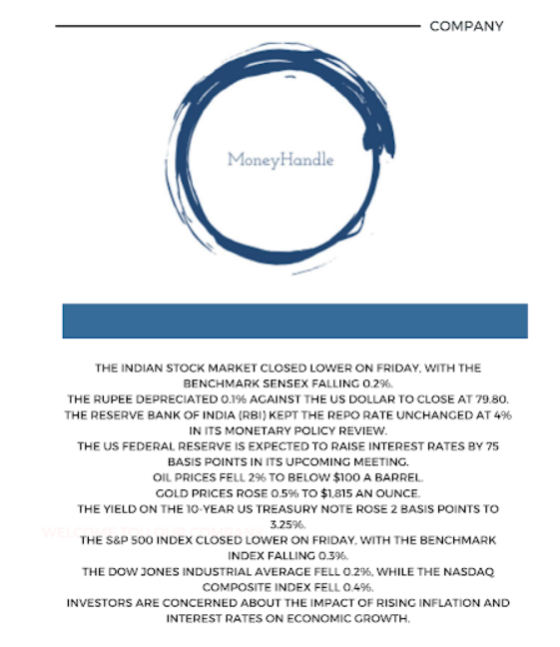

**INFOGRAPHIC:**

**LINK:** [**https://moneyhandlingforstudents.blogspot.com/2023/09/info-graphic.html**](https://moneyhandlingforstudents.blogspot.com/2023/09/info-graphic.html)



**FACEBOOK BUSINESS ACCOUNT**

**LINK:** [**https://www.facebook.com/people/Money-Handle/61550129867553/?mibextid=ZbWKwL**](https://www.facebook.com/people/Money-Handle/61550129867553/?mibextid=ZbWKwL)

